 |  | Westfield Infant School Skills Progression  EYFS Vision:  At Westfield Infant School we believe in developing the ‘whole’ child – socially, morally, emotionally and physically. In the Early Years, play is a strong motivating factor in learning and it is positively encouraged within the whole school environment both indoors and outdoors. Quality interactions are a part of our quality first teaching which allows pupils to develop their language, creativity and thinking skills, increasing their confidence.  We follow the Early Years Foundation Stage Guidance to promote a curriculum that teaches pupils to be inquisitive through their purposeful play and develop positive attitudes towards learning that are instilled, building confidence and resilience. Our safe, stimulating and inclusive environment encourages our pupils to explore, experiment, look, observe, touch, discuss and share their ideas freely.  Whole School Vision:  At Westfield Infant school we have developed a knowledge-rich curriculum based upon the extensive research around effective teaching and learning. We teach specific subject areas to enable our children to grasp a deep knowledge of different subject content, an understanding of how different subjects contribute to our world and to make connections between subjects in their learning.  Our curriculum is inclusive and aspirational, covering all aspects of the National Curriculum and interwoven with the core values of our school and the British values that enable children to grow into well-rounded, resilient and respectful citizens. Our aim is to equip children with rich subject knowledge which is built upon term by term, year on year, supporting children to remember what they have learnt and apply their knowledge in different situations. Westfield’s curriculum is underpinned by an understanding of how children learn. Rosenshine’s principles alongside relevant and related research have been used to design and deliver our curriculum to enable academic success and personal growth for all of our children.  “Knowledge forms the foundation of all higher order cognitive functions including critical thinking, problem-solving and decision-making.” Doug Lemov
Westfield Infant Schools Disciplinary Knowledge in Communication and Language
Skill | Autumn 1 |  | Autumn 2 | Spring 1 | Spring 2 | Summer 1 | Summer 2 |  | Early Learning Goal
Listening, Attention and Understanding  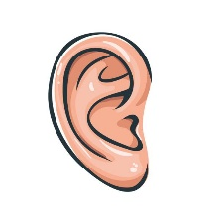 | To understand how to listen carefully  To understand why listening is important  To be able to follow directions |  | To engage in story times, joining in with repeated phrases and actions  To begin to understand how and why questions  To respond to instructions with more than one step | To ask questions to find out more  To begin to understand humour  To understand a range of complex sentence structures | To retell a story  To follow a story without pictures or props | To understand questions such as who, what, where, when, why and how | To have conversations with adults and peers with back and forth exchanges |  | Listen attentively and respond to what they hear with relevant questions, comments and actions when being read to and during whole class discussions and small group interactions. Make comments about what they have heard and ask questions to clarify their understanding. Hold conversations when engaged in back-and-forth exchanges with their teacher and peers.
Speaking   | To talk in front  of a small group  To talk to class teacher and LSAs  To learn new vocabulary |  | To answer questions in front of whole class.  To use new vocabulary throughout the day | To develop the confidence to talk to other adults they see on a daily basis.  To talk in sentences using conjunctions e.g. and, because | To share their work to the class- standing up at the front.  To use new vocabulary in different contexts  To engage in non-fiction books | To link statements and stick to a main theme  To use talk to organise, sequence and clarify thinking, ideas, feelings and events | To talk to different adults around the school  To talk about why things happen  To talk in sentences using a range of tenses |  | Participate in small group, class and one-to-one discussions, offering their own ideas, using recently introduced vocabulary. To talk to class teacher and LSAs To learn new vocabulary To use new vocabulary throughout the day To talk in sentences using conjunctions e.g. and, because To use new vocabulary in different contexts To engage in non-fiction books To use talk to organise, sequence and clarify thinking, ideas, feelings and events To talk about why things happen To talk in sentences using a range of tenses Offer explanations for why things might happen, making use of recently introduced vocabulary from stories, non-fiction, rhymes and poems when appropriate. Express their ideas and feelings about their experiences using full sentences including use of past, present and future tenses and making use of conjunctions, with modelling and support from their teacher.
Westfield Infant Schools Disciplinary Knowledge in Personal, Social and Emotional Development
Skill | Autumn 1 |  | Autumn 2 | Spring 1 | Spring 2 | Summer 1 | Summer 2 |  | Early Learning Goal
Self Regulation  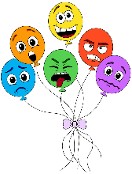 | To recognise different emotions  To understand how people show emotions  To focus during short whole class activities  To follow one step instructions |  | To talk about how they are feeling  To begin to consider the feelings of others  To adapt behaviour to a range of situations | To focus during longer whole class lessons  To follow two step instructions | To identify and moderate their own feelings socially and emotionally  To consider the feelings and needs of others | To control their emotions using a range of techniques  To set a target and reflect on progress throughout | To maintain focus during extended whole class teaching  To follow instructions of three steps or more |  | Show an understanding of their own feelings and those of others, and begin to regulate their behaviour accordingly. Set and work towards simple goals, being able to wait for what they want and control their immediate impulses when appropriate. Give focussed attention to what the teacher says, responding appropriately even when engaged in activity, and show an ability to follow instructions involving several ideas or actions.
Managing Self  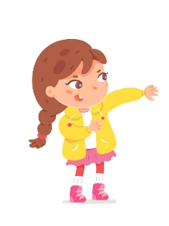 | To wash hands independently  To put coat and socks on independently  To get changed for P.E with support  To explore different areas within the Year R environment  To use the toilet independently |  | To develop class rules and understand the need to have rules  To put P.E kit on independently  To have confidence to try new activities | To begin to show resilience and perseverance in the face of challenge  To practise doing up a zipper | To develop independence when dressing and undressing for activities such as P.E and Outdoor Learning | To identify and name healthy foods  To manage own basic needs independently | To understand the importance of healthy food choices  To show resilience and perseverance in the face of challenge  To show a ‘can do’ attitude  To put uniform on and do up zippers and buttons with minimal support |  | Be confident to try new activities and show independence, resilience and perseverance in the face of challenge. Explain the reasons for rules, know right from wrong and try to behave accordingly. Manage their own basic hygiene and personal needs, including dressing, going to the toilet and understanding the importance of healthy food choices
Building Relationships  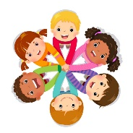 | To seek support of adults when needed  To gain confidence to speak to peers and adults |  | To play with children who are playing with the same activity  To begin to develop friendships  To have positive relationships with all Year R staff | To begin to work as a group with support  To use taught strategies to support turn taking | To listen to the ideas of other children and agree on a solution and compromise | To work as a group  To begin to develop relationships with other adults around the school | To have confidence to communicate with adults around the school  To have strong friendships |  | Work and play cooperatively and take turns with others. Form positive attachments to adults and friendships with peers. Show sensitivity to their own and to others’ needs.
Westfield Infant Schools Disciplinary Knowledge in Physical Development
Skill | Autumn 1 |  | Autumn 2 | Spring 1 | Spring 2 | Summer 1 | Summer 2 |  | Early Learning Goal
Gross Motor Skills   | To move safely in a space  To stop safely  To develop control when using equipment  To follow a path and take turns  To work co-operatively with a partner |  | To balance  To run and stop  To change direction  To jump  To hop  To explore different ways to travel using equipment | To roll and track a ball  To develop accuracy when throwing to a target  To dribble using hands  To throw and catch with a partner  To dribble a ball using feet  To kick a ball to a target | To create short sequences using shapes, balances and travelling actions  To balance and safely use apparatus  To jump and land safely from a height  To develop rocking and rolling  To explore traveling around, over and through apparatus  To create short sequences linking actions together and including apparatus | To move safely with confidence and imagination, communicating ideas through movement  To explore movement using a prop with control and co-ordination To move with control and co-ordination, expressing ideas  through movement To move with control and co-ordination, copying, linking and repeating actions  To remember and repeat actions, exploring pathways and shapes | To develop accuracy when throwing and practise keeping score  To follow instructions and move safely when playing tagging games  To learn to play against an opponent  To play by the rules and develop coordination  To explore striking a ball  and keeping score  To work cooperatively as a team |  | Negotiate space and obstacles safely, with consideration for themselves and others. Demonstrate strength, balance and coordination when playing. Move energetically, such as running, jumping, dancing, hopping, skipping and climbing.
Fine Motor Skills  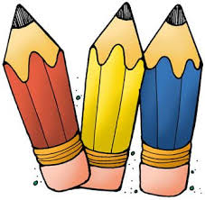 | To use a dominant hand  To mark make using different shapes  To begin to use a tripod grip when using mark making tools  To use tweezer to transfer objects To thread large beads  To use large pegs  To begin to copy letters  To hold scissors correctly and make snips in paper  To hold a fork and spoon correctly |  | To begin to use anticlockwise movement and retrace vertical lines  To hold scissors correctly and cut along a straight and zigzagged lines  To use a tripod grip when using mark making tools To accurately draw lines, circles and shapes to draw pictures  To write taught letters using correct formation  To begin to hold a knife correctly and use to cut food with support  To use tap and pin | To use a tripod grip when using mark making tools  To hold scissors correctly and cut along a curved line  To thread small beads  To use small pegs  To write taught letters using correct formation | To hold scissors correctly and cut out large shapes  To write letters using the correct letter formation and control the size of letters | To hold scissors correctly and cut out small shapes  To copy letters using a correct directional formation  To paint using thinner paintbrushes | To hold scissors correctly and cut various materials  To create drawings with details  To copy letters using a lead in and lead out  To independently use a knife, fork and spoon to eat a range of meals |  | Hold a pencil effectively in preparations for fluent writing- using the tripod grip in almost all cases. Use a range of small tools including scissors, paintbrushes and cutlery. Begin to show accuracy and care when drawing
Westfield Infant Schools Disciplinary Knowledge in Literacy
Skill | Autumn 1 |  | Autumn 2 | Spring 1 | Spring 2 | Summer 1 | Summer 2 |  | Early Learning Goal
Comprehension   | To use pictures to tell stories  To sequence familiar stories  To independently look at book, holding them the correct way and turning pages |  | To engage in story times, joining in with repeated phrases and actions  To begin to answer questions about the stories read to them  To enjoy and increasing range of books including fiction, non-fiction, poems and rhymes | To act out stories  To begin to predict what may happen in the story  To suggest how a story might end | To retell a story  To follow a story without pictures or props  To talk about the characters in the books they are reading | To begin to answer questions about what they have read  To use vocabulary that is influenced by their experiences of books | To answer questions about what they have read To know that information can be retrieved from books |  | Demonstrate understanding of what has been read to them by retelling stories, and narratives using their own words and recently introduced vocabulary. Anticipate (where appropriate) key events in stories. Use and understand recently introduced vocabulary during discussions about stories, non-fiction, rhymes and poems and during role play.
Word Reading  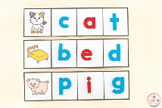 | To recognise their name  To recognise taught Phase 2  To recognise taught Phase 2 Tricky Words  To begin to blend sounds together to read words using the taught sounds |  | To recognise taught Phase 2 sounds  To recognise taught Phase 2 Tricky Words  To blend sounds to read words using taught sounds  To read words ending with s e.g. hats, sits  To read words ending with s /z/ e.g. his, bags  To begin reading captions and sentences using taught sounds  To read books matching their phonics ability | To recognise taught Phase 2 and 3 sounds  To recognise taught Phase 2 and 3 Tricky  Words  To read words with double letters  To begin to read longer words  To recognise taught digraphs in words and blend the sounds together  To read sentences containing Tricky Words and digraphs  To read books matching their phonics ability | To recognise taught Phase 2 and 3 sounds  To recognise taught Phase 2 and 3 Tricky  To read sentences containing Tricky Words and digraphs  To read books matching their phonics ability | To recognise taught Phase 2 and 3 sounds  To recognise taught Phase 2 and 3 Tricky Words  To read longer words including those with double letters  To read words with s/z/ in the middle To read words with -es/z/ at the end To read words with s and s/z/ at the end  To read sentences containing Tricky Words and digraphs  To read books matching their phonics ability |  | To recognise taught Phase 2 and 3 sounds  To recognise taught Phase 2, 3 and 4Tricky Words  To read  words with phase 3 long vowel sounds with adjacent consonant  To read longer words  To read compound words To read words ending in suffixes To read longer sentences containing Phase 4 words and Tricky Words  To read books matching their phonics ability |  | Say a sound for each letter in the alphabet and at least 10 digraphs. Read words consistent with their phonic knowledge by sound-blending. Read aloud simple sentences and books that are consistent with their phonic knowledge, including some common exception words
Writing  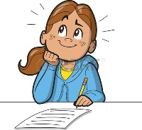 | To copy their name  To give meanings to the marks they make  To copy taught letters  To write initial sounds  To begin to write CVC words using taught sound |  | To write their name  To use the correct letter formation of taught letters #To write words and labels using taught sounds  To begin to write captions using taught sounds | To form lowercase letters correctly To begin to write sentences using fingers spaces  To understand that sentences start with a capital letter and end with a full stop  To spell words using taught sounds  To spell some taught tricky words correctly | To form lowercase letters correctly and begin to former capital letters  To write sentences using finger spaces and full stops  To spell words using taught sounds  To spell some taught tricky words correctly | To form lowercase and capital letters correctly  To begin to copy letters  To begin to write longer words which are spelt phonetically  To begin to use capital letters at the start of a sentence  To use finger spaces and full stops when writing a sentence  To spell some taught tricky words correctly  To begin to read their work back | To form lowercase and capital letters correctly  To copy letters  To begin to write longer words and compound words which are spelt phonetically  To write sentences using a capital letter, finger spaces and full stop  To spell some taught tricky words correctly  To read their work back and check it makes sense |  | Write recognisable letters, most of which are correctly formed. Spell words by identifying sounds in them and representing the sounds with a letter or letters. Write simple phrases and sentences that can be read by others.
Westfield Infant Schools Disciplinary Knowledge in Mathematics
Skill | Autumn 1 |  | Autumn 2 | Spring 1 | Spring 2 | Summer 1 | Summer 2 |  | Early Learning Goal
Number  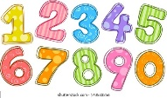 | To recognise numbers 1-3  To begin to subitise to 3  To find one more of numbers to 3  To find one less of numbers to 3 To explore the composition of 2 and 3 |  | To recognise numbers 1-5  To begin to subitise to 5  To find one more of numbers to 5  To find one less of numbers to 5 To explore the composition of 4 and 5 | To recognise numbers 0-8  To subitise to 5 To find one more of numbers to 8 To find one less of numbers to 8  To explore the composition of 6, 7 and 8  To match the number to quantity | To recognise numbers 0-10  To explore the composition of 9 and 10  To practise number bonds to 10  To know addition facts to make 5 To find one more of numbers to 10 To find one less of numbers to 10 To estimate a number of objects | To recognise numbers to 20  To revise number bonds to 5  To explore how to make numbers above  ten using tens and ones  To match the number to quantity | To solve simple number problems To recap the composition of each number to 10  To know addition and subtraction facts to 10  To know doubling facts |  | Have a deep understanding of number to 10, including the composition of each number. Subitise (recognise quantities without counting) up to 5. Automatically recall (without reference to rhymes, counting or other aids) number bonds up to 5 (including subtraction facts) and some number bonds to 10, including doubling facts.
Numerical Patterns  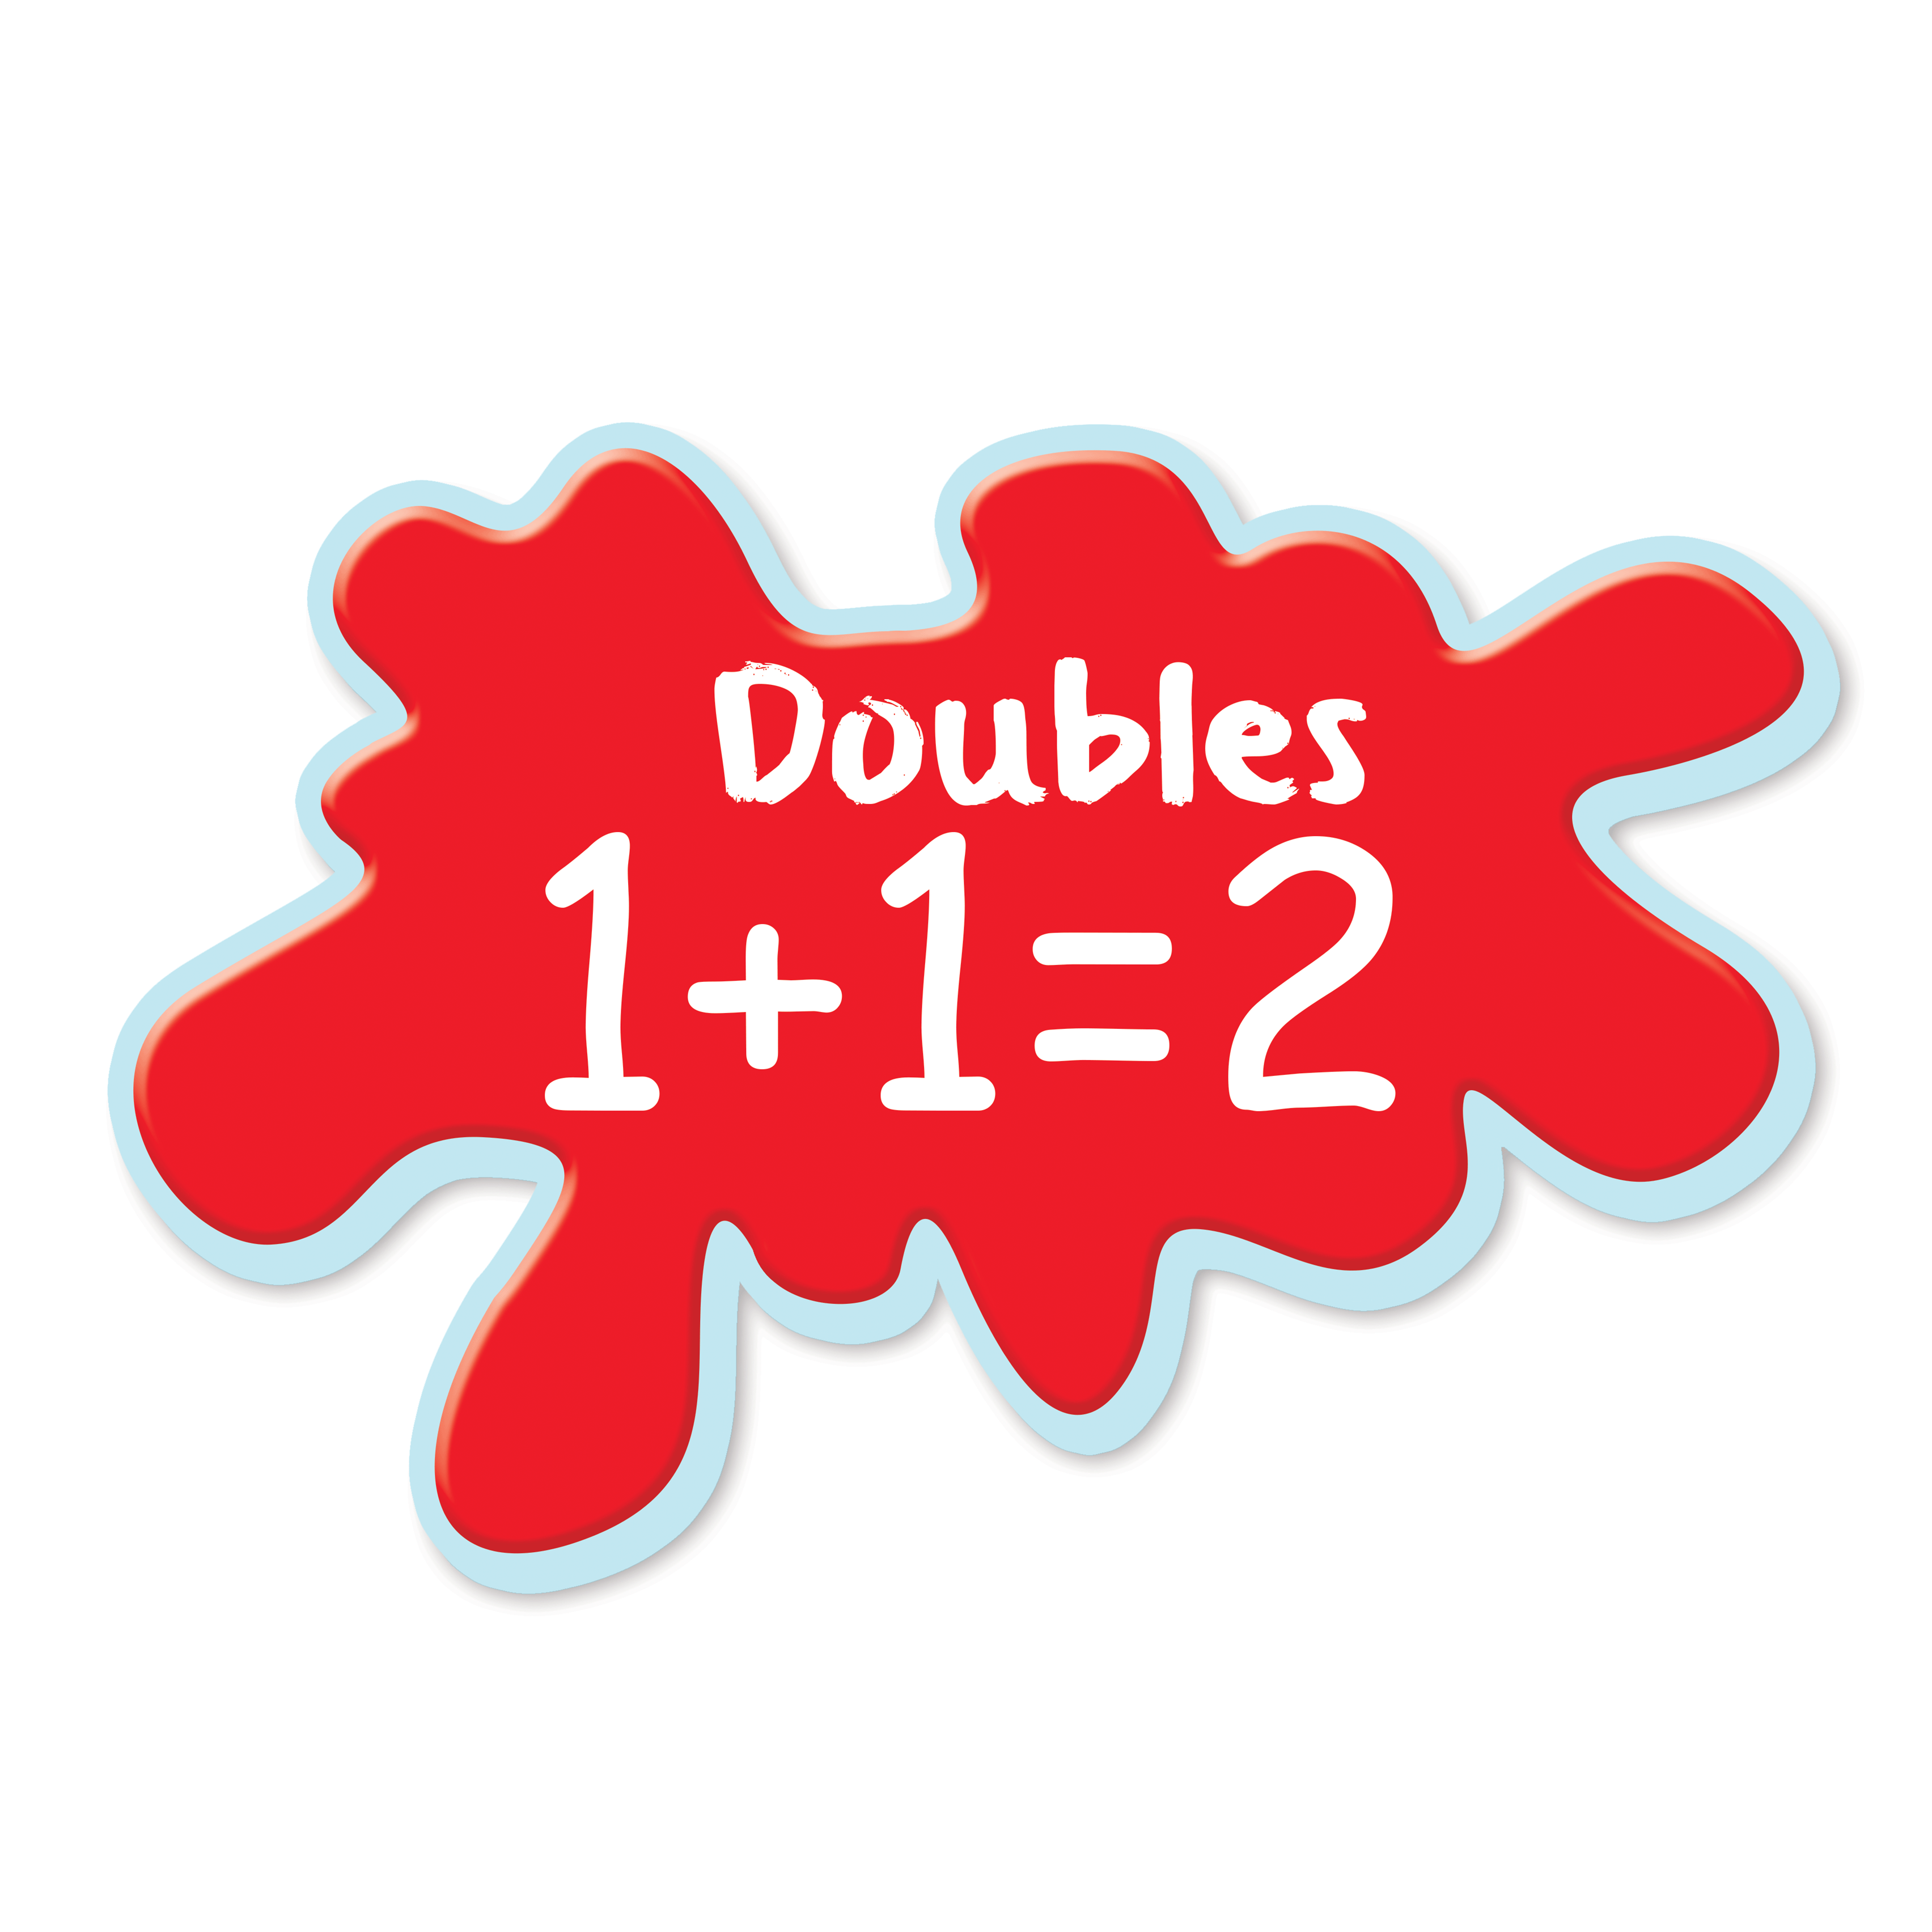 | To say which group has more  To say which group has less  To compare quantities to 3  To count to 5 |  | To compare quantities to 5  To compare equal and unequal groups  To count to 10 | To count to 15  To count objects to 10 To compare quantities to 8  To begin to understand the different between odd and even numbers up to 8  To combine two groups of objects | To count to 20  To compare quantities to 10 To explore odd and even numbers To order numbers to 10 To count back from 10  To combine two groups of objects To take away objects and count how many are left To find the missing number | To count to 25  To add numbers To subtract numbers  To find the missing number  To order numbers to 20  To order numbers e.g. 13, 15, 19  To find the missing number in an addition and subtraction sentence problems | To count to 30 and beginning to count higher (100).  To know that 1, 3, 5, 7 and 9 are odd To know that 2, 4, 6, 8, 10 are even To double numbers up to 10 To find half of numbers up to 10 To share quantities equally To combine groups of 2s, 5s and 10s |  | Verbally count beyond 20, recognising the pattern of the counting system. Compare quantities up to 10 in different contexts, recognising when one quantity is greater than, less than or the same as the other quantity. Explore and represent patterns within numbers up to 10, including evens and odds, double facts and how quantities can be distributed equally
Shape, Space & Measure  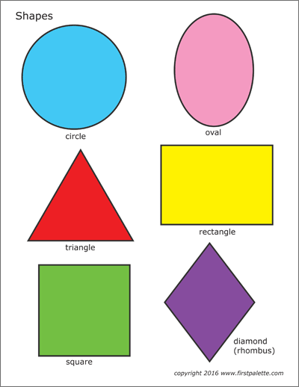 | To match objects To sort objects  To compare capacity, length, height, size.  To finish a repeating pattern of 2 objects or colours  To recognise and name circle and triangle |  | To recognise and name square and rectangle | To order objects by height and length  To order the days of the week  To measure height using cubes  To measure time To begin to name 3D shapes  To explore the properties of 3D shapes | To name 3D shapes  To explore the properties of 3D shapes | To measure capacity  To describe the properties of 3D shapes  To make pictures with shape arrangements | To finish a repeating pattern  To make patterns using shapes  To name and describe 2D and 3D shapes |  | There are no early learning goals that directly relate to shape, space and measure objectives. However, children will have experienced rich opportunities to develop their spatial reasoning skills in shape, space and measure
Westfield Infant Schools Disciplinary Knowledge in Understanding The World
Skill | Autumn 1 |  | Autumn 2 | Spring 1 | Spring 2 | Summer 1 | Summer 2 |  | Early Learning Goal
Past and Present  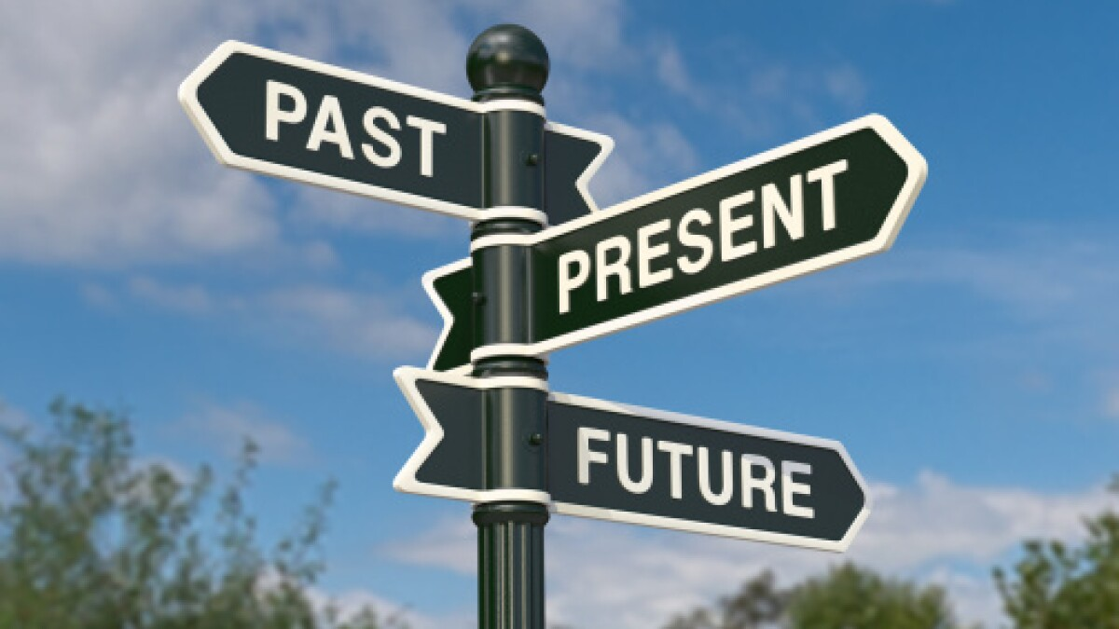 | To know about my own life-story  To know how I have changed  To talk about the lives of the people around us.  To know that the emergency services exist and what they do |  | To know some similarities and differences between things in the past and now, drawing on experiences and what has been read in class (Christmas) | To know some similarities and differences between things in the past and now, drawing on experiences and what has been read in class  To know about figures from the past (Neil Armstrong and Tim Peake, Galileo) | To know about the past through settings, characters and events encountered in books read in class  (Farming)  To understand and talk about the changes in farming over the years | To know about the past through settings, characters and events encountered in books read in class  To recount the events surrounding the Magna Carte  To comment and discus the Coronation | To know some similarities and differences between things in the past and now, drawing on experiences and what has been read in class  To recall and discuss stories from ancient Greece, legends and different cultures |  | Talk about the lives of the people around them and their roles in society. Know some similarities and differences between things in the past and now, drawing on their experience and what has been read in class. Understand the past through settings, characters and events encountered in books read in class and storytelling.
People, Culture and Communities   | To know about family structures and talk about who is part of their family  To identify similarities and differences between themselves and peers.  To know about features of the immediate environment.  To know that there are many countries around the world. |  | To talk about how Hindus celebrate Diwali  To talk about the Christmas Story and how it is celebrated  To know that people around the world have different religions  To identify transport in our local area and around the world | To talk about Chinese New Year. To know about people who help us within the local community  To talk about features of our planet, planets in our solar system and space exploration | To know that Christians celebrate Easter.  To discuss farming in our local area; what crops are grown where we live? Identify fruit and vegetables that can be grown locally, or within the local region. Identify where the fruit and vegetables we eat come from. | To recount facts about The Monarchy; Queen Elizabeth II,KC the Royal Family, To recognise features of countries around the world that have King Charles as their monarch including; Canada, Jamaica, New Zealand, Australia and more.  To recognise the UK flag and its significance. | To locate the places that feature in the key stories chosen for this topic.  To discuss oral storytelling as part of culture; how we pass on stories within our families and communities. |  | Describe their immediate environment using knowledge from observation, discussion, stories, non-fiction, texts and maps. Know some similarities and differences between different religious and cultural communities in this country, drawing on their experiences and what has been read in class. Explain some similarities and differences between life in this country and life in other countries drawing on knowledge from stories, non-fiction texts and (where appropriate) maps.
The Natural World   | To ask questions about the natural environment.  To respect and care for the natural environments  To recall facts about The human body: Facial features, body parts, the senses  To make observations about the season of Autumn |  | To know about and recognise the signs of Autumn  To understand Forces: push, pull, twist  To make observations about the season of Winter. Animal hibernation,  To identify methods of transport in the winter;  To develop an understanding of the changing state of matter; | To know about our planet Earth, land and sea, plants and animals, weather, gravity. The moon, the sun, the planets in our solar system, space travel, astronauts.  To make observations about Spring. | To know about growing and changing; how people change as they grow, how animals change as they grow.  To talk about the life cycles of a butterfly & frog.  To identify and draw animals and their babies  To observe the growth of seeds and talk about changes  To identify parts of plants including roots, stem and leaves. | To make observations about the season of Summer.  To develop a design of a garden for the King; what could we grow? What would we include?  To ask questions to develop understanding. | To know about and recognise the signs of Summer.  To recall how we stay safe in the sun;  To understand safety around water.  To develop an understanding of Changing state of matter; Why do our ice lollies melt? |  | Explore the natural world around them, making observations and drawing pictures of animals and plants. Know some similarities and differences between the natural world around them and contrasting environments, drawing on their experiences and what has been read in class. Understand some important processes and changes in the natural world around them including the season and changing states of matter
Technology   | To show an interest in technological toys such as IWB, iPads, toys with knobs, pulleys and buttons  To learn about esafety |  | To know how to operate simple equipment  To draw pictures on IWB and begin to change colours  To use the iPad to take pictures | To access, understand and interact with a range of technology within the Year R environment  To draw pictures on IWB, changing colour and pen size | To use the IWB, changing games and programmes | To explore how a Bee-Bot works To use the internet with adult supervision to find and retrieve information | To begin to give reasons why we need to stay safe online  To use the BeeBots and program them to go forwards and backwards |  | There are no early learning goals that directly relate to computing objectives, though it is still expected that children will be introduced to appropriate technology and use it within their provision.
Westfield Infant Schools Disciplinary Knowledge in Expressive Arts and Design
Skill | Autumn 1 |  | Autumn 2 | Spring 1 | Spring 2 | Summer 1 | Summer 2 |  | Early Learning Goal
Creating with materials   | To name colours To experiment with mixing colours  To create simple representations of people and objects  To draw and colour with pencils and crayons  To role play using given props and costumes  To explore techniques for joining materials (Glue Stick)  To use different construction materials |  | To use colours for a particular purpose  To share their creations  To explore different techniques for joining materials (Glue Stick, PVA) To know how to work safely and hygienically  To use nonstatutory measures (spoons, cups) | To experiment with different mark making tools such as art pencils, pastels, chalk  To develop control with the drip technique  To explore  different techniques for joining materials (Glue Stick, PVA, Masking Tape, Tape)  To know how to work safely and hygienically | To discuss what we can see in the world around us. To use techniques to create Lowry and drawing our own houses and “matchstick” people.  To make observations of the architecture of Hundertwasser to inspire us to draw imaginary houses. | To know which prime colours you mix together to make secondary colours  To manipulate materials  To create observational drawings  To study Rousseau’s “Tiger in a Tropical Storm”.  To use ink and wax resist to paint real fish. | To know some similarities and differences between materials To learn about people in art. Looking at Degas’ ballerinas.  To manipulate clay to create sculptures of “Miro-like” people.  To share creations, talk about process and evaluate their work  To adapt work where necessary |  | Safely use and explore a variety of materials tools and techniques, experimenting with colour, design, texture, form and function. Share their creations, explaining the process they have used. Make use of props and materials when role playing characters in narratives and stories
Being imaginative and expressive  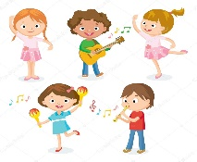 | To sing & perform nursery rhymes  To experiment with different instruments and their sounds  To talk about whether the like or dislike a piece of music  To create musical patterns using body percussion  To use costumes and resources to act out narratives |  | To perform a song in the Christmas Play  To learn and perform a poem at the Christmas Concert  To pitch match  To sing the melodic shape of familiar songs  To begin to build up a repertoire of songs  To sing entire songs  To use costumes and resources to act out narratives | To join in with whole school singing assemblies  To create musical patterns using untuned instruments  To begin to create costumes and resources for role play | To perform songs at the Easter Assembly  To join in with whole school singing assemblies  To associate genres of music with characters and stories  To create costumes and resources for role play | To move in time to music  To learn dance routines  To join in with whole school singing assemblies  To act out well know stories  To follow a musical pattern to play tuned instruments  To create narratives based around stores | To join in with whole school singing assemblies  To create own compositions using tuned instruments  To invent their won narratives, making costumes and resources |  | Invent, adapt and recount narratives and stories with peers and their teacher. Sing a range of well know nursery rhymes and songs. Perform songs, rhymes, poems and stories with others and (when appropriate) try to move in time with music

